


For Immediate Release: Performance Date: March 12, 2026
Contact: Liz Pelton, Fullcircledanceco@gmail.com
Kamala Lyons, Klyons@jcc.org
LINEAGE
Ballet Theatre of Maryland and Full Circle Dance Company
Together for One Night

Two of Maryland’s top professional dance companies—Ballet Theatre of Maryland and Full Circle Dance Company—will unite this spring in a performance that explores ideas of heritage and legacy, with special focus on the contributions of women. The show LINEAGE will be presented one night only, Thursday, March 12, 2026, at the Gordon Center for Performing Arts.

Blending the grounded power of modern dance and the soaring sweep of ballet, LINEAGE shines a light on mothers and matriarchs as sources of creativity and sustenance. Each company will present works that illuminate the theme, and dancers from both ensembles will share the stage in rousing final work that will have the audience clapping and stomping along.

LINEAGE will also invite members of the audience to participate directly in the artistic process in a small but deeply personal way. One of the works on the program features a quilt created by a local artist that reflects real stories of female ancestors. Before the performance, audience members will be invited to write on bits of fabric the names of their own female ancestors. These fabric scraps will be inserted inside the quilt, honoring the ancestors of the LINEAGE audience in a concrete way on the stage.

LINEAGE marks the third fruitful collaboration between two companies that belong to different dance traditions but that share many values and creative interests.

“Both of these professional companies are genuinely interested in innovating together,” said Full Circle Artistic Director Donna L. Jacobs. “Ballet and modern dance diverge in many ways, and they are inheritors of many different legacies, but they also share some important roots. In LINEAGE, we can explore the great value in our differences as well as our common ground. It is inspiring, and artistically enriching, for us to be together on this journey.”

“This collaboration is deeply meaningful to Ballet Theatre of Maryland,” said Artistic Director Nicole Kelsch. “Working alongside Full Circle Dance Company allows us to celebrate the distinct voices of ballet and modern dance while honoring the women whose legacies shape both our lives and our artistry. Ballet and modern dance carry different traditions, yet both are shaped by generations of women whose creativity, strength, and resilience continue to guide us; and LINEAGE invites our audiences to reflect on this heritage—not as something distant, but as something living, shared, and personal.”

“The Gordon Center is thrilled to be the host and home for this creative partnership with the support of the Maryland State Arts Council Touring Grant,” said Sara Shalva, the Gordon Center’s Chief Arts Officer. “This type of performance, which blends styles and genres, and builds relationships on stage and off, is exactly the mission centered work our Baltimore County based performing arts center is called to do.”

Performance Details

LINEAGE:
Ballet Theatre of Maryland and Full Circle Dance Company
Thursday, March 12, 2026, 7:30 pm
Gordon Center for Performing Arts
3506 Gwynnbrook Avenue
Owings Mills, MD 21117
Tickets: $15-$35, https://gordoncenter.com/event/lineage/

To arrange media interviews with the artists or to attend a rehearsal preview, please contact fullcircledanceco@gmail.com.

LINEAGE is made possible by a Maryland State Arts Council Touring Grant and is supported in part by the Arts Council of Anne Arundel County, the Maryland State Arts Council, Baltimore Office of Promotion and the Arts, The Gordon Center/JCC of Greater Baltimore, and The Associated: Jewish Federation of Baltimore.

About the Companies

The Ballet Theatre of Maryland, under the direction of Nicole Kelsch, is Maryland’s premier professional ballet company. Located in Annapolis, the company provides audiences with over 20 full-length performances each season in both classical and contemporary ballet. Along with a trainee and apprentice program, the BTM Conservatory of Dance offers training and education to aspiring dancers of all ages. BTM believes in the power of dance to inspire and enrich lives, which is why the company partners with numerous local community organizations to make dance accessible to all regardless of background or socioeconomic status. Through these collaborations, the company continues to inspire and uplift diverse audiences across the state.

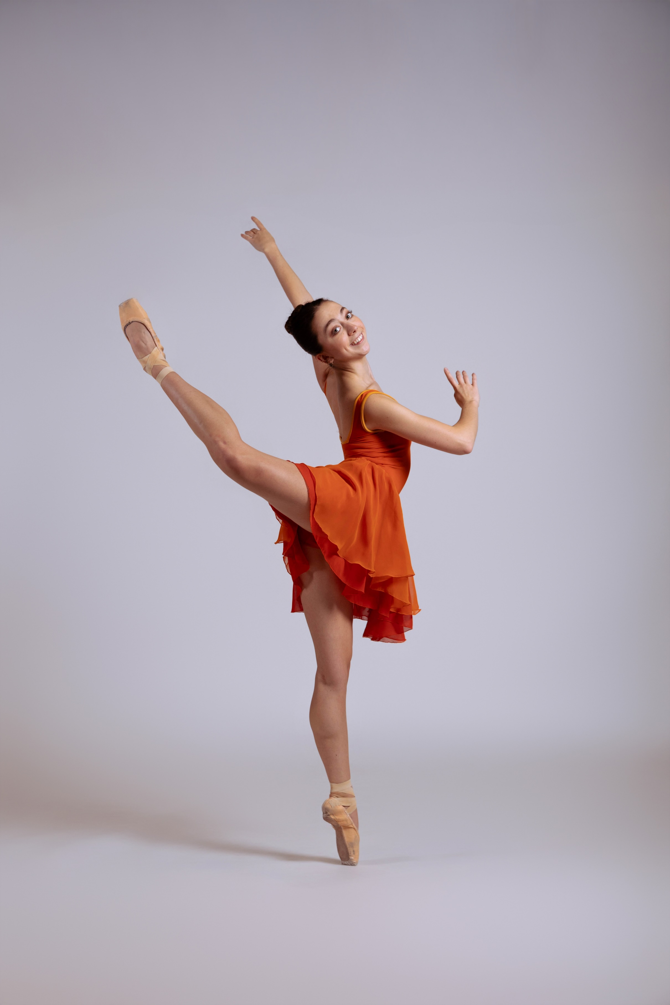

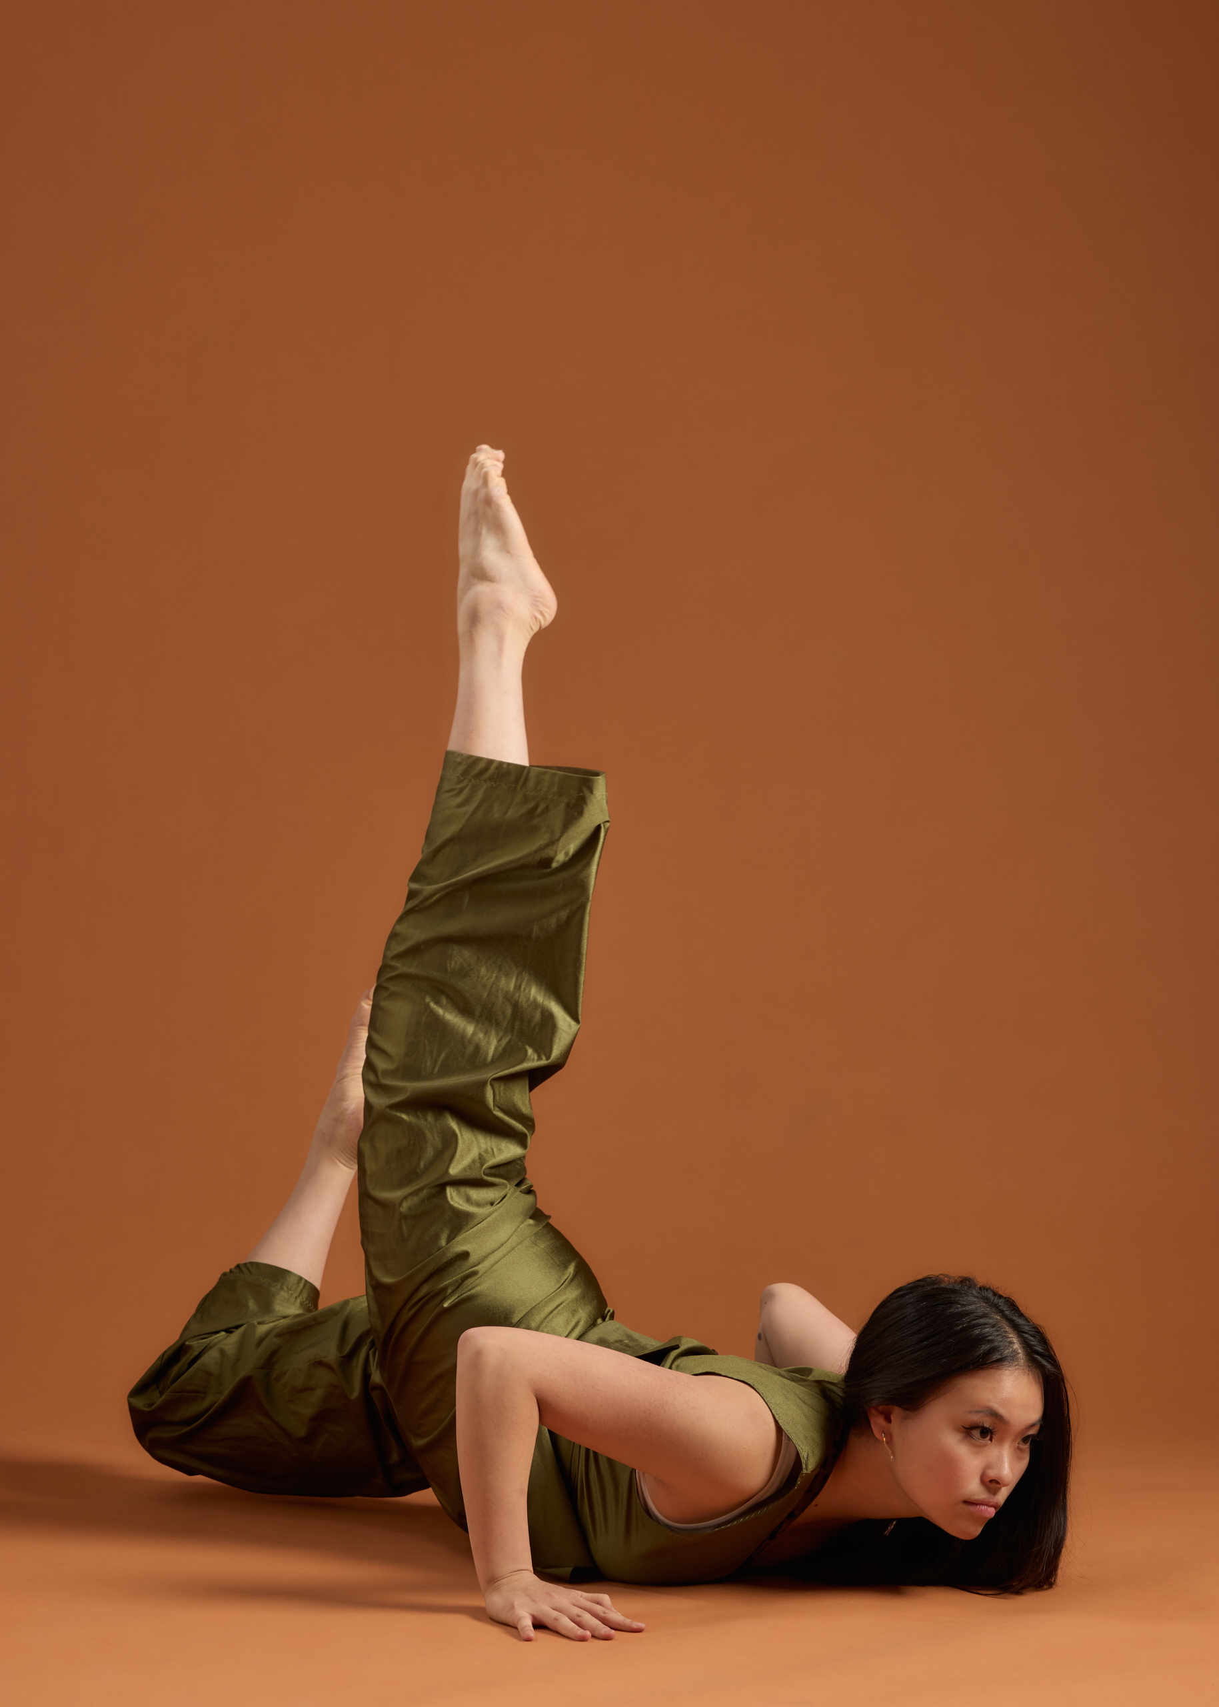
Full Circle Dance Company, under the direction of Donna L. Jacobs, is a multiracial professional ensemble that performs exciting choreography from a variety of modern dance traditions. Based in Baltimore, the company works in a collaborative spirit to create meaningful dance with universal appeal. Founded in 2000, the company explores a theme each year, commissioning work from multiple choreographers on that theme, creating opportunities to involve members of the community in the creative process, and presenting the new works together to offer varied perspectives on each topic. Full Circle has given free workshops at Roland Park Elementary Middle School, Irvine Nature Center, Baltimore Museum of Art, and Baltimore City Cancer Program as well as at its home studio, The Morton Street Dance Center.

